1. Turtle tagging
1.1 Nesting turtles
A total of 206 nesting green turtles were encountered on the beaches around the atoll (table 1.1). Of the 50 ‘already tagged’ individuals located, 21 turtles were tagged in previous years (table 2.1). As usual, most turtles showed high fidelity to their nesting beaches. Nonetheless, one turtle that was tagged on the settlement beach was seen ashore at Anse Malabar only a week later (20km away).
Almost a quarter of the turtles were encountered on the 2km long settlement beach (figure 1.1) where they were seen in increasing numbers with an increasing distance from the station.
The number of untagged turtles encountered versus tagged individuals has remained fairly stable over the years (figure 1.2).
One nesting hawksbill turtle was tagged at beach 50c in December.

Table 1.1: The number of turtles handled in 2004

 | Total handled | Total tagged | Total old tags
Nesting green turtles | 206 | 156 | 50
Nesting hawksbill turtles | 1 | 1 | 1
Juvenile green turtles | 162 | 105 | 57

Table 2.1: The number of recaptured turtles tagged prior to 2004

1997 | 1998 | 1999 | 2000 | 2001 | 2002 | 2003
5 | 4 | 2 | 5 | 5 | 0 | 0

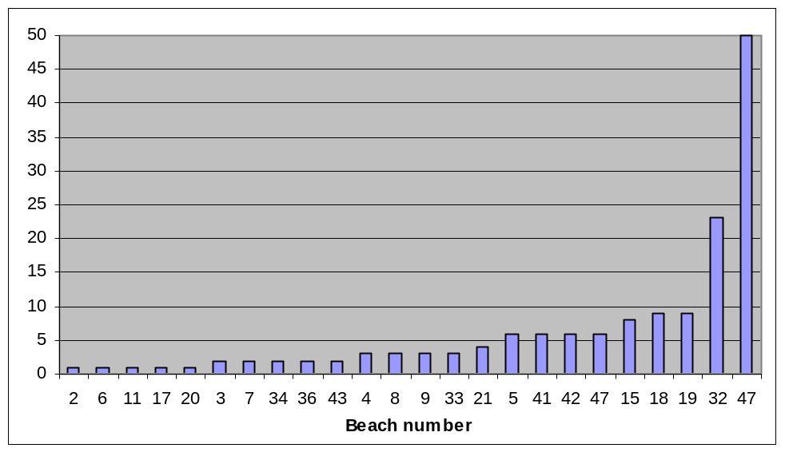

Figure 1.1: The number of nesting green turtles tagged at various beaches in 2004

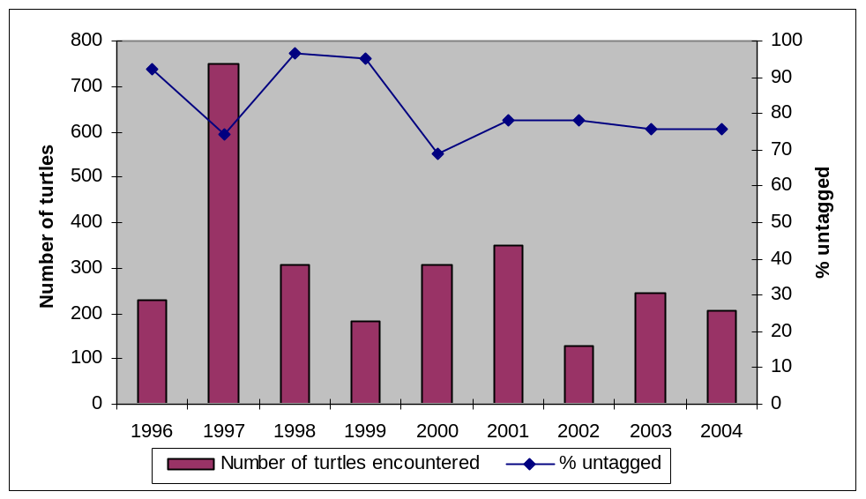

Figure 1.2: The number of turtles encountered and the corresponding percentage of
untagged individuals over the years

1.2 Juvenile green turtles
Of the 57 recaptured juvenile green turtles, one was tagged in 2001, one in 2002 and 18 in 2003. The large majority (65%) of the turtles were captured at Ile Moustique. The shallow, clear water and sandy conditions around this lagoon island are favourable for rodeo activities. Even though so many turtles were tagged around Ile Moustique, the percentage of untagged individuals between the capture locations is fairly constant (figure). This suggests that juveniles move between these locations indeed, a few turtles that were captured at Ile Esprit were recaptured at Ile Moustique (and vice versa).

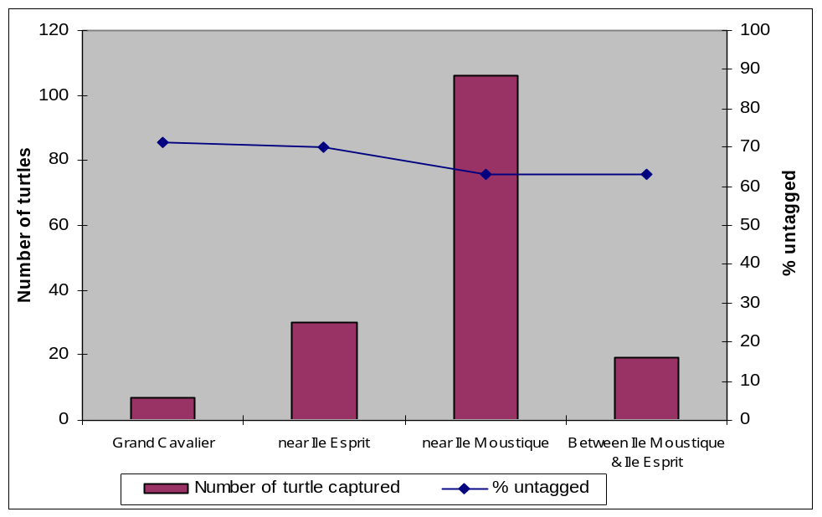

Figure 1.3: The number of juvenile turtles captured at the various rodeo locations and the
corresponding percentage of untagged individuals over the years
1.3 Inaccuracy of morphometric measurements
On inspection of the tagging data, it was noted that a high degree of inaccuracy between morphometric measurements of the same individuals was evident. In order to test this assumption, measurements of turtles that were measured more than once during 2004 were compared. An ‘inaccuracy index’ was calculated through the division of the difference of like measurements by the larger of the two measurements.
Specifically: inaccuracy index = (x¹ - x² / xmax) * 100. The 2003 data was dealt with in the same manner in order to facilitate a comparison between the two years. For nesting green turtles a 186% increase in inaccuracy was found from 2003 to 2004. In other words, tagging personnel were three times less accurate when measuring the turtles in 2004. Figure 1.4 shows that the ‘tip to tip’ and ‘width’ measurements were taken with particularly poor accuracy (see figure 1.6 for description of measurement parameters). For juvenile turtles, an increase of 48% in inaccuracy was found (i.e. measurements in 2004 were half as accurate as in 2003). From figure 1.5, tagging personnel were particularly careless with both the ‘over the curve’ and ‘straight line’ width measurements.
It must be noted that this is not attributable to a lack of training as accuracy improves dramatically when some supervisory pressure is applied. I believe that these shortcomings and the majority of other careless errors are based on a lack of concern rather than a lack of adequate training.

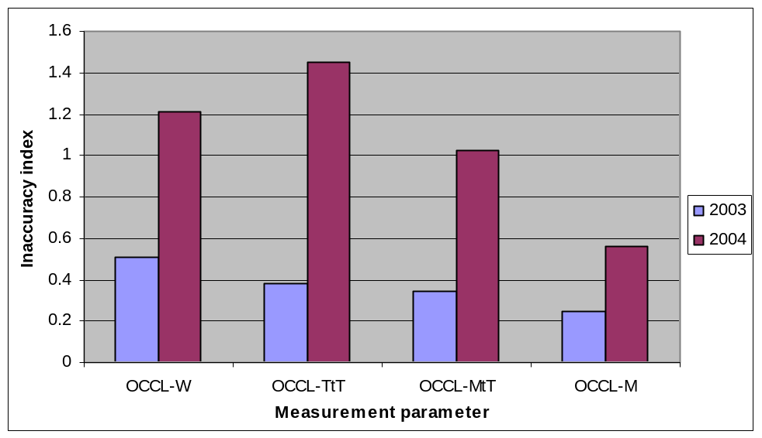

Figure 1.4: Mean inaccuracy indices for nesting green turtle carapace measurements in 2003
and 2004 (OCCL = ’Over the curve’)
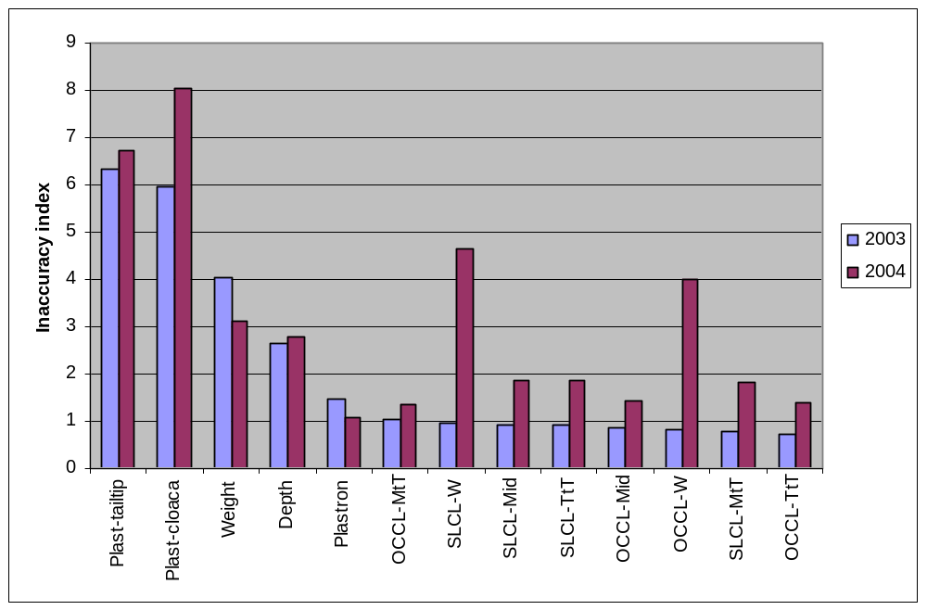

Figure 1.5: Mean inaccuracy indices for juvenile green turtle morphometric measurements
for 2003 and 2004 (OCCL = ‘Over the curve length’, SLCL = ‘straight line
length’)

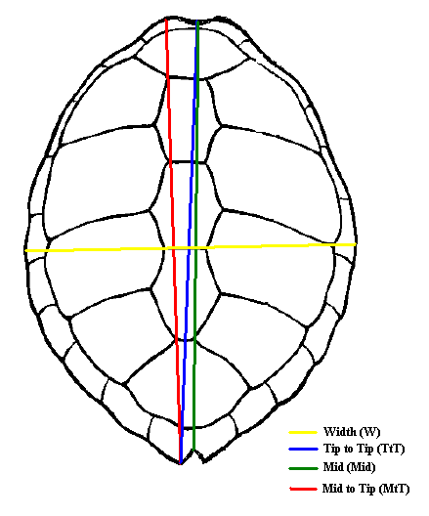

Figure 1.6:Carapace measurements of nesting and juvenile green turtles (nesting turtles only
OCCL, juvenile turtles OCCL + SLCL)
2. Track counts
Figure 1.7 shows the number of track counts conducted at each of the 47 ‘outer rim’ beaches in 2004. The frequency of counts is roughly in line with the required minimum (Mortimer 1997). Extrapolating from the sum of the settlement beach and West Grande Terre counts, 2004 provided average numbers of nesting green turtle emergences (if one only looks at the last 6 years). The high numbers of turtles recorded in 2001 is yet to be surpassed. Only 3 Hawksbill tracks were recorded on lagoon beaches.

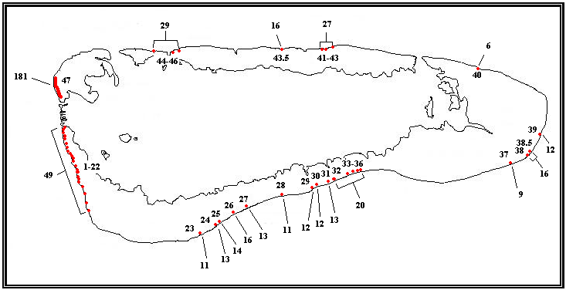
Figure 1.7: The number of track counts conducted per beach. 1-22, West Grande Terre; 23-27, Dune
D’Messe region; 28-36, Dune Jean Louis region; 37-39, Cinq Cases region; 40, Anse Cedres;
41-43.5, Anse Malabar region; 44-46, Gionnet region; 47, settlement beach

At the settlement and West Grande Terre beaches, nest site selection has followed similar annual patterns. At the settlement beach, nesting frequency increases with an increasing distance from the station and at West Grande Terre, turtles favour the larger and more stable beaches (figure 1.8).

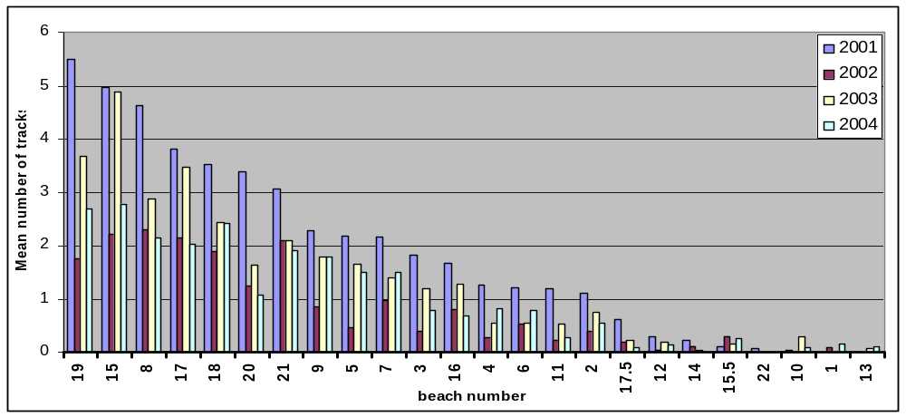

Figure 1.8: mean number of VF tracks per beach 2000 - 2004
Over the last 6 years, nesting seasonality has not followed the bi-modal pattern as reported in earlier years (Mortimer et al). At the settlement beach a single peak during March/April has been evident since 1999, (with the exception of 2000 where no seasonality occurred) confidence intervals show that this seasonal pattern is well established (figure 1.9). The West Grande Terre beaches show more variability in annual nesting seasonality. Nevertheless, at least the last two years seem to be conforming to the single March/April peak pattern (figure 1.10).

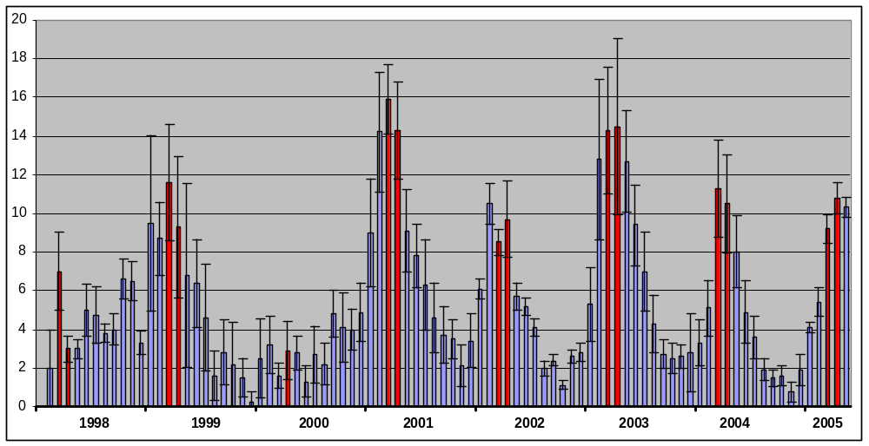
Figure 1.9: Monthly mean numbers of VF tracks on the settlement beach between 1998 and
May 2005 showing 95% confidence intervals. Red columns represent the months
of March and April.

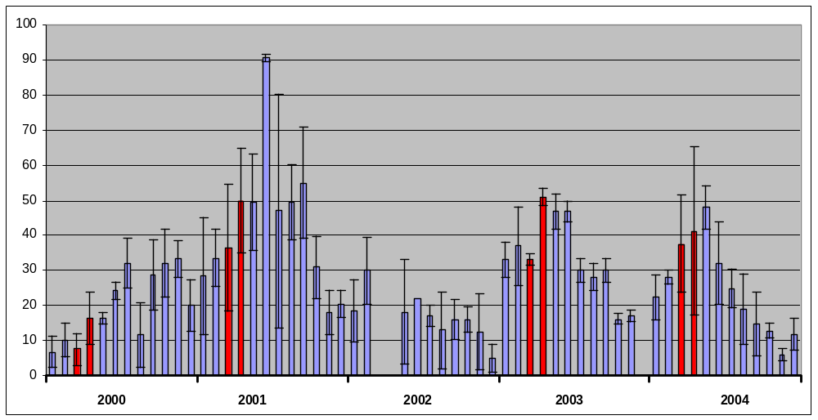

Figure 1.10: Monthly mean numbers of VF tracks along West Grande Terre beaches
between 2000 and 2004 showing 95% confidence intervals. Red columns
represent the months of March and April.

